A BRIEF HISTORY OF THE COINAGE OF SRI LANKA
By Graeme J. Stephens

- Introduction
Sri Lanka is a large island located close to the south east coast of India with an area of about 65000 square kilometres and a population of about 20 million. For size comparison, it is almost exactly the same area as the island of Tasmania.

Besides Lanka, the other names by which this island has been known over the centuries are Lanka (Sanskrit), Lakdiva (Sinhala), Taprobane (Greek and Roman), Ceilao (Portuguese) and Zeilan (Dutch). Sri Lanka is a beautiful and very fertile island which has always had about it an aura of the exotic. The Chinese called it the “Island of Jewels”, the Greeks and the Romans the “Land of the Ruby”, and the Hindus, the “Pearl upon the Brow of India”.

- Historical Overview
Sri Lanka has had a long and fascinating history. From around 483BCE when Vijaya landed with his 700 followers from India and became the Chief Ruler of the Island a well documented chronology of over 180 Kings and Queens exists in the literature up to the last King of Kandy in 1815. In 1505 the Portuguese subjugated the coastal area of the island and maintained colonial control for 153 years. In 1658 the Dutch East India Company (VOC) with the capture of Jaffna finally ousted the Portuguese and maintained their own colonial control for 138 years. In 1796 the British seized the Dutch Colony and made Lanka a British Crown Colony in 1802. In 1948, after 146 years of British colonial rule, Lanka became an independent self-governing dominion of the British Commonwealth. In 1972 Lanka became the Republic of Sri Lanka.
Each of the above eras in Sri Lanka’s history is represented by a rich legacy of coinage and my collection contains excellent examples of all of these periods up to independence. The text covers the period from 250BCE to 1825 when the currency reverted to British Sterling. As the island has been known as Sri Lanka only in modern times I will refer to it throughout the text as its ancient and medieval name, Lanka.

- Earliest Coinage – Kashapanas (250BCE-200CE)
The earliest coins in Lanka are known as kashapanas or puranas. These are flat pieces of silver cut from sheets or thin bars and trimmed to the correct weight and then stamped with various punch marks. They can be round, rectangular, square or multi-sided. They received strikes from several (5 is the common number on the obverse; 1 is usual on the reverse) punches that vied with each other for position on the surface. Most are only partially on the flan and often overlap at least one other of the punches. Each punch mark had its own particular meaning and over 300 have been identified by numismatic scholars. The punch marks include many objects including trees, animals, symbols of Buddhist worship, solar and planetary signs. The precise meaning of the punch marks is not certain but it has been suggested that they could represent a series of officials in diminishing order of authority, and that the always present symbol, the sun, would represent the King himself, and the various forms of the six armed emblem the highest officials next under him. It is thought that circulation of these coins ranged from about 250BCE to at least 200CE. They are written of as being in use in the reign of King Dutugamunu in the second century BCE and scholars have documented their use into the start of the Roman period. Puranas are also well known from the same period in India but can usually be distinguished from those of Lankan origin by unique combinations of punch marks. The enlarged photo shows a group of these small coins.

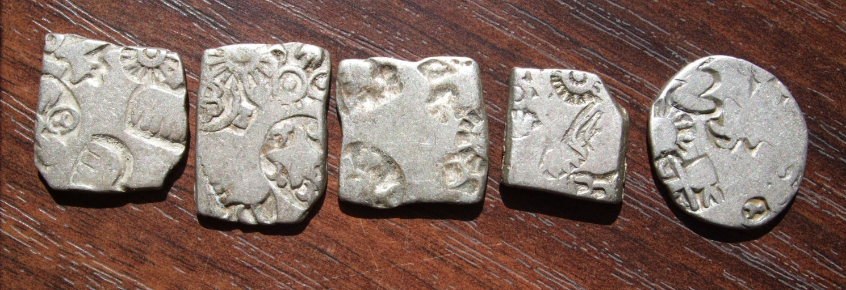

Silver Karshapanas or Puranas

- Lakshmi Plaques (1st Century BCE to 3rd Century CE)
These are rectangular pieces of Copper with a stylised figure of the goddess Lakshmi on the obverse and a railed swastika revolving to the right (or sometimes to the left) on the reverse. The plaques can be either cast or struck and their tenure has been uncertain. It is currently thought that they were used in the general period from 100 BCE to 300CE.
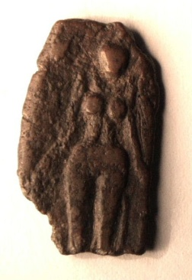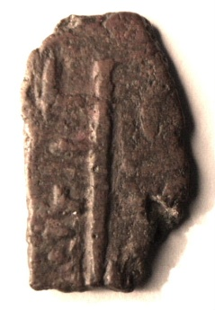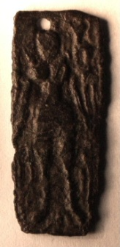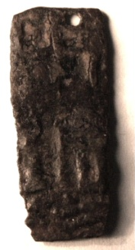
Cast Lakshmi Plaque Struck Lakshmi Plaque

- Elephant and Swastika (1st Century BCE to 3rd Century CE)
These are rare and ancient Buddhist themed copper coins. Their tenure is thought to be about the same as the cast Lakshmi Plaques, from about 100 BCE to about 300 CE. Buddhism was introduced to Lanka from India in 247 BCE. On the obverse there is a stylised elephant, walking left, above which is a symbol of three hills thought to represent mountains (“caitya”) with a railed swastika and a tree in an enclosure as well as the “dhajaya” and other Buddhist symbols. The reverse contains similar symbols but without the elephant and including the curious “nandipada”. Some of these symbols have been interpreted to represent phases in the life of Buddha with the elephant representing his birth, the railed tree his enlightenment, the railed swastika his ministry, and the Caitya his death. The dhajaya is seen as his standard. There are two types known. The type found at Anuradhapura is thin and struck with fine detail while the second type found at Tissmaharama in South West Lanka is thick and rough cast. An example of the former type is shown below.
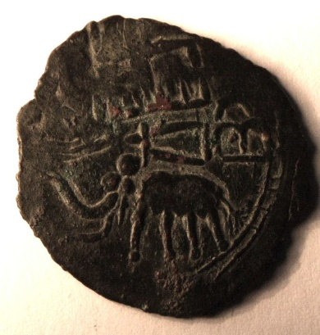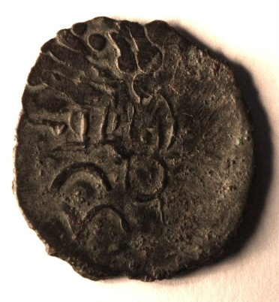
Elephant and Swastika Coin

- Maneless Lion (2nd to 3rd Century CE)
These copper coins have been attributed to the 2nd and 3rd Centuries by Lingen and were certainly still in use during the reign of King Mahasena (277-304CE). The specimen shown in the photo is well worn (as most are) but shows the maneless lion on the obverse and the four dots in a circle on the reverse.

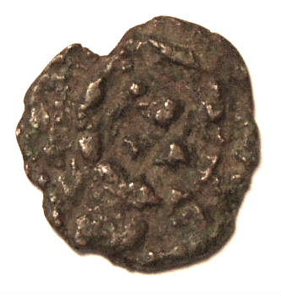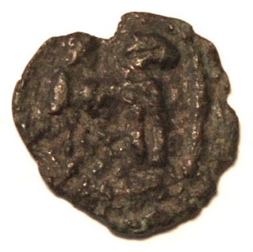
Cakram Maneless Lion

- Roman Coins (3rd Century to mid 7th Century)
Roman coins and contemporary local imitations of Roman coins were in wide circulation in Lanka for a period of at least four centuries, starting in the third century CE. Lanka was situated on the maritime trade routes between Rome and China and traded many commodities such as jewels, pearls, camphorwood, spices and ebony with the Romans over this long period. The Roman historian Pliny the Elder recorded that four ambassadors of Taprobane were sent to Rome during the reign of King Chandhrakuma Siva (44-52AD) and it is probable that some Lankan trade commenced at that time. Large hoards of copper or bronze Roman coins and contemporary Indo-roman imitations have been found at many places in Lanka with a large hoard being found in 1987 at Sigiriya. The coins are always very worn indicating a wide and constant circulation and the roman coins are usually third century and later in age. These hoards suggest that the roman and indo-roman coinage was probably used as small change long after the minting date of the coins themselves. A group of these coins is shown in the photo.

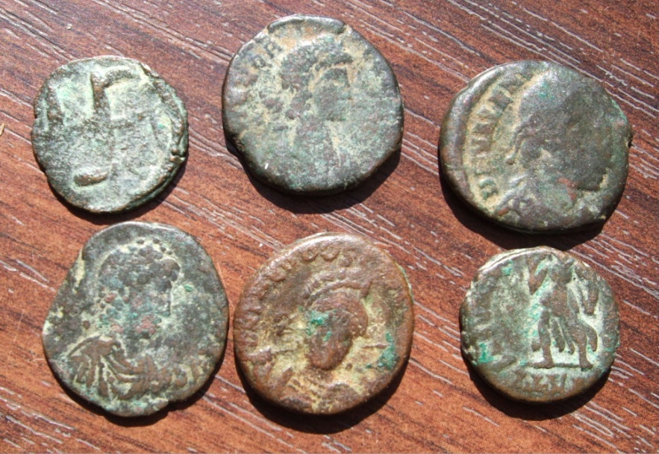
Roman and Indo Roman coins of Third and Fourth Centuries

Occasional gold trade coins from Rome are also found in Lanka with an example shown below of a Byzantine Roman solidus of Heraclius and Heraclius Constantine (610-641CE).
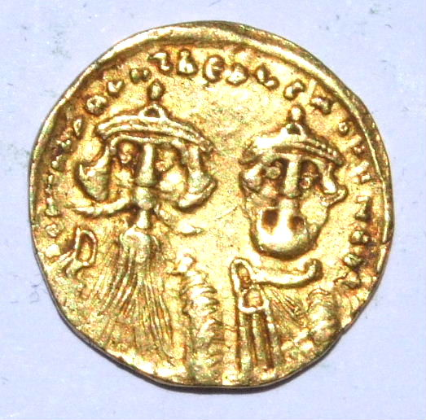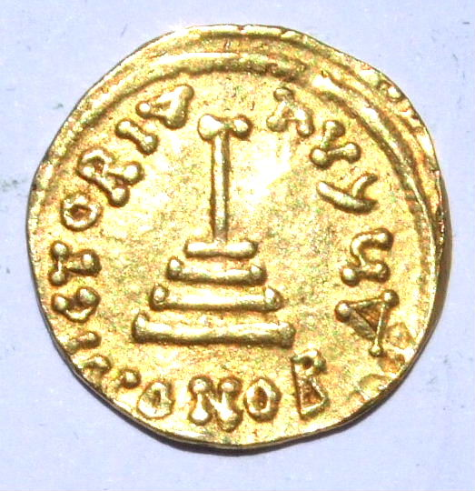
Roman Gold Solidus of Heraclius found in Lanka

- Indian Gold Dinar of Samudragupta (333-375CE)
Samudragupta was ruler of the Gupta Empire in Central and Northern India from 333 to 375 and is considered to be one of the greatest military geniuses in Indian History. He was the son of Chandragupta and ushered in the so called “Golden Age of India” He was a benevolent ruler, a great warrior, and a great patron of the arts. His military conquests obtained for him supreme control over the northern three quarters of modern India. The coin shown is a gold dinar showing Samudragupta standing on the obverse surrounded by official symbols and script. On the reverse is the goddess Lakshmi seated on a throne. The figure of Lakshmi on these coins is said to be the inspiration for the reverse of the Sri Lankan Kahavanu series of coins described below, and this was one of a number of Indian coins that were used in Lanka from time to time during trade with India.
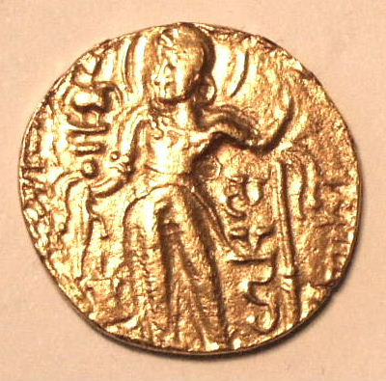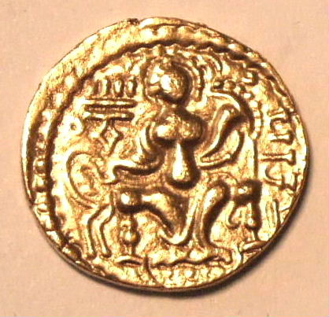
Gold Dinar of Samudragupta (India)
- Pallava (668-740AD)
The Pallavas were Kings of Southern India who controlled Lanka for nearly two centuries through a series of puppet Sinhala kings starting with Manavanna in the late seventh century and finishing with Aggabodhi IX in the mid ninth century. Pallava copper coins cover the period 668 to 740 AD and cover a variety of types. The pallava coin shown is a thick copper coin with a large vase sitting on a drum and holding a branched plant with a lamp symbol on either side. On the reverse is a large flowering tree held in a small vase flanked on one side by a bull and the other side by an elephant.
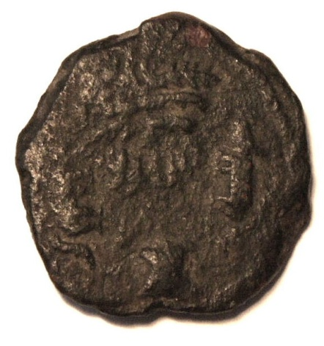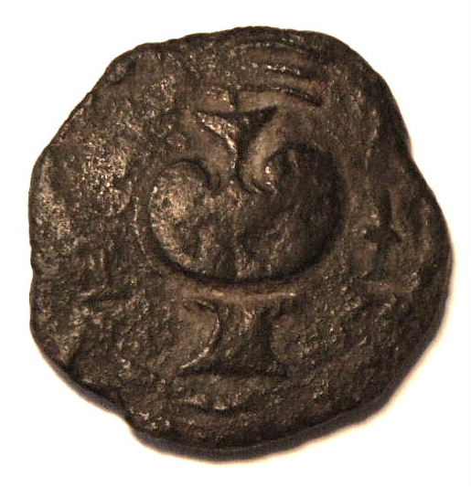
Pallava Vase Coin
- Early Pandyan Coins (824-943CE)
The Pandyans were a dynasty of Indian Rulers who by the mid ninth century had risen to a position of ascendancy over the Pallavas in the southernmost region of India and controlled the fishing grounds in the Gulf of Mannar as well as the rich pearling grounds between India and Lanka in Palk Bay. After unsuccessfully invading Lanka in the mid-ninth century the Pandyans continued to exert considerable influence in Lanka and continued to trade. The Pandyan coins found in Lanka are copper and date to the period 824-943. The two examples shown in the photos are as follows:
- Kongu Cera
Obverse – Elephant facing right, trunk pendant, in front a symbol (?), over back, a conch.
Reverse – Bull facing left, in front, lamp, over back a crescent.
- Bull Series
Obverse – humped bull sitting right, underneath two lines, over back, a crescent, on either side a lamp.
Reverse- Two fish facing opposite directions, underneath a crescent, over two lines, a thin lamp on each side, all in a beaded circle.
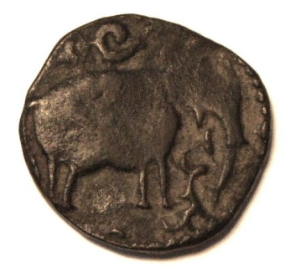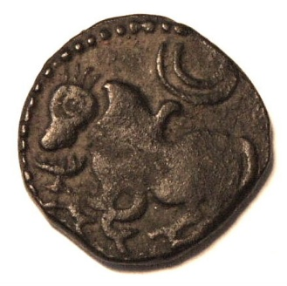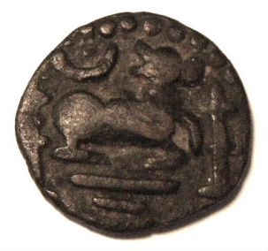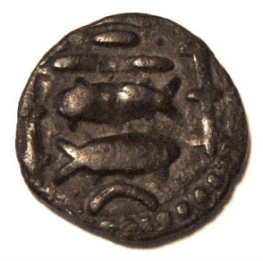
Pandyan Kongu Cera Coin Pandyan Bull Series Coin

- Medieval Gold Coins of the late House of Lambakanna II Period (8th Century-1017CE)
This anonymous gold coinage appears to have been initiated in the 8th Century long before RajaRaja Chola invaded Lanka in 990 and struck through the period the Cholas dominated the island. The standard gold coin produced was the kalanda (or kahavanu) of about 4.4 – 4.5 gms in weight. There were also fractional coins of gold with the half being called an ada, the quarter being called a pala and the eighth being called an aka.
The design of these first kahavanu coins is derived from Sinhala symbolism and formed the basic design motive of coins in Lanka for the next 900 years. It is now known widely as the “massa” design. On the obverse is a standing male figure, crowned and clothed in a dhoti. The figure is thought to be Kuvera, the King of Demons. He is standing on a sailing craft represented by a curved line of dots with a symbol at either end. In the right field of the coin is a group of three or four small circles, each with a dot in the centre. The right arm of the figure is extended with the hand and elbow over two symbols, the inner srivatsa symbol, and the outer lamp symbol. The left hand holds aloft one of a number of symbols. On the reverse side we have the same figure also holding a symbol in the left hand (which can be the same or different symbol to the obverse) but squatting on an oblong enclosure, divided lengthwise by a line and subdivided by vertical cross lines, the nidhi-kostha, or treasure deposit. On the left side of the figure (the right side of the coin) appears the legend in Nagari characters, commonly read as Sri Lamka Vibhu, the “Fortunate Lord of Lanka”. The following symbols held in the left hand can be recognised on these coins :
Lotus, jasmine flower, adahanda or half moon (a crescent consisting of two small semi-circles, one within the other), chank (shaped like a lying down question mark), trident, full pot, ball, annulet, sun and moon emblem, flower, and srivatsa.
None of this series of coins identified the ruler on the coin. It will not be until after the Chola Occupation in another century that the Sinhala kings start to put their names on these “massa” coins. Codrington has however devised a scheme whereby various types of these anonymous gold kahavanus can be grouped as to origin, and he has recognised three types. The collection contains :
- A Type II Kahavanu together with matching pala and aka. They are all of the adahanda & lotus type and all three
are beautiful gold coins.
(b) A Type III Kahavanu of the jasmine and chank combination.
There appeared to be little or no copper coinage minted in Lanka during this period except for the Chola Coinage from 990 (described below) and smaller transactions would therefore have required the smaller gold fractional coins to be in frequent use as well as a smaller copper coinage such as the roman and indo-roman coins already mentioned. The photos show all four coins described above (not to scale).
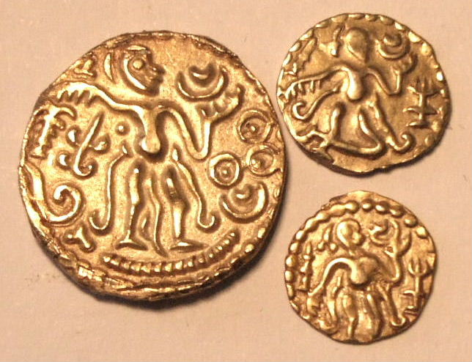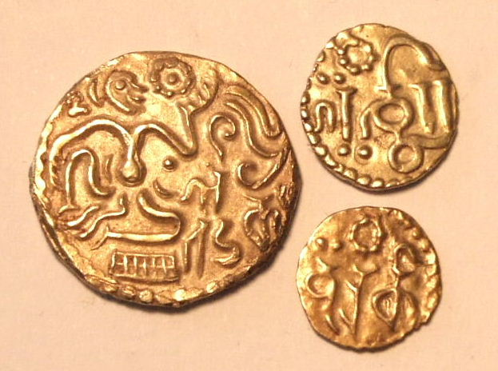

Type II Gold Kahavanu – Adahanda and Lotus with Matching Pala and Matching Aka
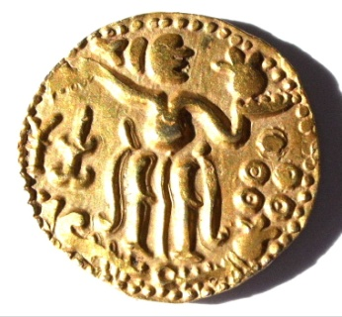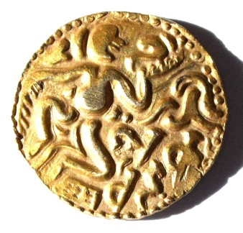
Type IIIB Gold Kahavanu- Jasmine and Chank

- Chola Occupation coinage (990-1070CE)
The Chola’s were one of the longest reigning dynasties in medieval India and ruled the southeastern portion of India from the late ninth to the thirteenth centuries. The period of Chola occupation of Lanka began in 990 when RajaRaja Chola sent a large Chola army which conquered northern Lanka and added it to the Chola Empire. The rest of Lanka was annexed by his son Rajendra Chola in 1017, however the dispossessed Sinhala Monarchs continued to exercise some authority from the Ruhana region in the south of the island when they were not subjected to Chola attacks. In 1070 the Sinhala King Vijayabahu occupied Polonnaruwa and succeeded in making a largely peaceful settlement with the Cholas who withdrew to India.
The Cholas struck a gold, silver and copper coinage in Lanka. The gold and copper coinage of Rajaraja simply copied the “massa” style local gold coins which were then in use among the local Sinhala. An example of the gold coinage (somewhat debased) is shown below, and the other example is a copper “massa” type coin of a curious convex shape and of rough execution. There are no examples of the silver Chola coinage in the collection.
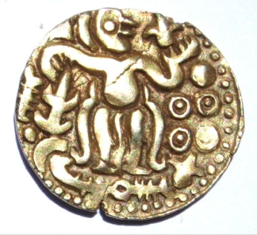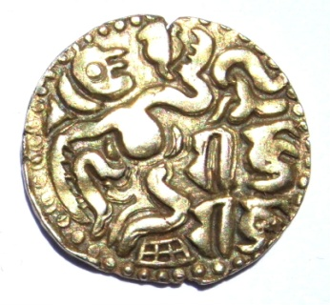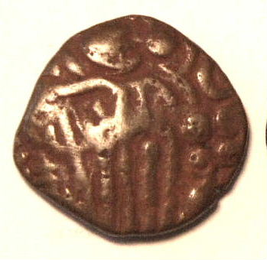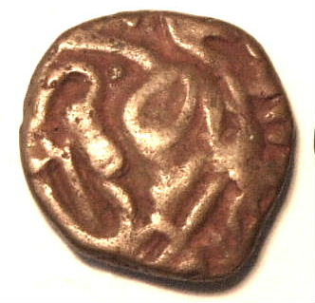
Debased Gold Kahavanu of RajaRaja Chola (985-1014) Copper Massa of Chola Type

- Five Kingdoms Period (1056-1505)
This long period covered five separate Kingdoms of Sinhala Kings occupying six separate capitals at Anuradhapura, Polonnaruwa, Dambadeniya, Kurunegala, Gampola, and Kotte. Aside from some minor gold coinage of the first King Vijaya Bahu I (1056-1111) almost all of the coinage output was in the form of copper “one massa” coins, with Parakrama Bahu I (1153-1186) and Dharmasoka (1208-1209) also producing small 1/8 massa coins. On the obverse of all these coins is a standing human figure very similar to the obverse of the Kahavanu coinage and on the reverse is the same seated figure with a legend giving the ruler’s name. The following monarchs issued massa coins:
- Vijaya Bahu I (1056-1111)
- Parakrama Bahu I (1153-1186)
- Nissanka Malla (1187-1196)
- Codaganga (1196-1197)
- Queen Lilivati (1197-1200)
- Sahasa Malla (1200-1202)
- Dharmasoka (1208-1209)
- Parakrama Bahu II (1234-1268)
- Vijayabahu IV (1268-1270)
- BuvanakaBahu (1271-1283)
- Parakrama Bahu VI (1412-1467)
The photos show the reverse of massa coins minted by four of these rulers. The reverse is shown because only this side of the coin contained the Ruler’s name in Devanagari script.

COPPER MASSA COINS
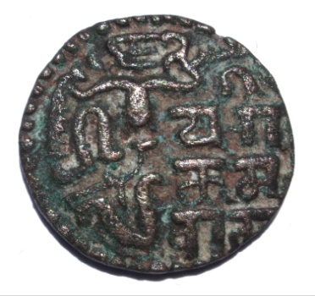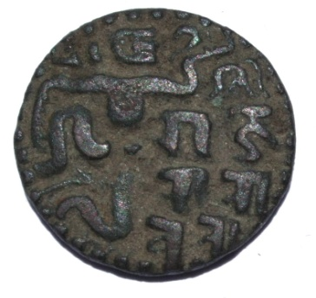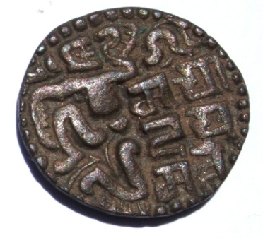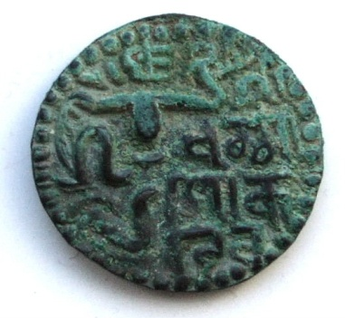Parakrama Bahu I (1153-1186) Queen Lilivati (1197-1200) Sahassa Malla (1200-1202) Dharmasoka (1208-1209)

- The Sethu Coinage from Jaffna (1215-1619)
The Sethu coins are a class of copper coin originating from the autonomous Hindu Kingdom of Jaffna in the Tamil speaking northern part of the island with Jaffna as its capital. After Kalinga Magha invaded Lanka from India in 1215 with Pandyan support he established the Jaffna Kingdom and ruled Lanka until his death in 1236. After that time the Jaffna Kingdom continued to exist as a tribute paying feudality of the Pandyan Empire in India. Upon the defeat in India of the Pandyans in 1323 the Jaffna Kingdom became independent and for a brief period in the early to mid 15th century again became the ascendant power in Lanka. Around 1450 it was overpowered and subjugated to the control of the Kotte Kingdom in the south and never again ruled Lanka. However it did retain its independence and continued as a Kingdom until 1619 when it fell under Portuguese control. There are two types of Sethu coins and the one shown is a copper Type II Arya Chakravati of 1462-1597. The obverse has the usual “massa” style but the reverse shows a reclining bull with large Tamil letters beneath reading Sethu.
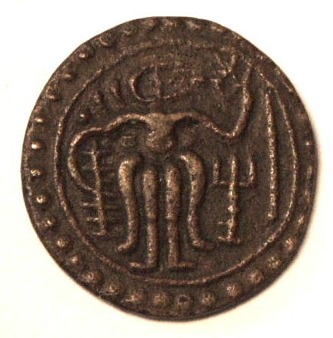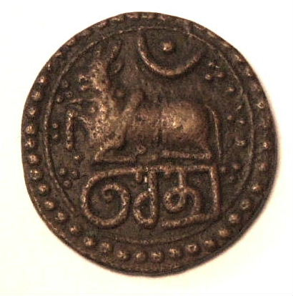
Type II Arva Chakravati Of Jaffna Kingdom 1462-1597

- The Gold Fanam and Sinhala Silver Panama
The gold fanam is a very small gold coin used in Lanka over a long period. Its origins are not at all clear but it is considered that these were trade coins from the Malabar Coast of India and in use from the fourteenth to the sixteenth centuries. They are only 8 mm in diameter and have distinctive patterns on each side but no script or date. The Sinhala silver panama on the other hand is a copy of the gold fanam and was minted by the Sinhala Kings in the seventeenth century during the Portuguese occupation and used well into the Dutch period (see below) The photos show a group of each of these tiny coins.
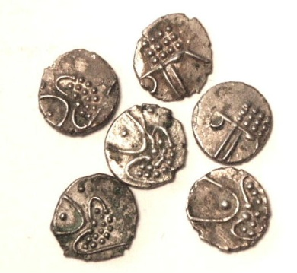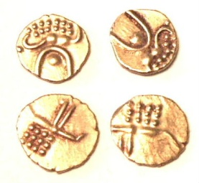
Silver Panamas Gold Fanams

- The Portuguese Annexation (1505-1658)
In 1505 Francisco de Almeida, newly appointed first Portuguese Viceroy of the East, despatched his son to explore commercial prospects southwards from the Portuguese seat at Cochin in China. He returned in 1506 with a treaty from the King of Lanka, Parakramabahu VIII, who agreed to pay tribute in cinnamon and elephants. During 1509/10 the new Governor in Cochin, Alfonso de Albuquerque, established Portuguese maritime supremacy in the Indian Ocean and sailed on eastwards, establishing Malacca in present day Malaysia in 1511. In 1512 Lopo Soares de Albergaria (who became Viceroy in 1515) established the first Portuguese Trading Settlement in Lanka in Colombo. During ensuing years further trading settlements were opened around the coast of Lanka and in 1597 the Portuguese King Philip I (1580-1598) was proclaimed sovereign of Ceilao (Lanka), followed by Philip II (1598-1621), Philip III (1621-1640), and John IV(1640-1656).
In practice, however, the Portuguese only ruled the coastal lands and the Sinhala Kings of Kandy remained paramount in the interior of the island while the Tamil Jaffna Kingdom in the north retained its independence until 1619. Portuguese coinage struck in, or for, Ceilao all appears to post date the declaration of Philip’s suzerainty in 1597. Local striking was ordered to cease in 1634, but had been resumed by 1640 when undated “gridiron” tangas were being struck. Local minting continued until at least 1645, but from about 1642 most silver coin destined for use in Ceilao was struck at Goa (India). Circulation of “St John” type silver coins was forbidden at Goa in 1650 when replaced by the “Cross of Christ” type silver coin however the Goa mint continued strikings of St John issues for use in Ceilao until 1653.
In 1638 the King of Kandy, Rajasinghe II called on the Dutch for help against the Portuguese and in 1658 the last Portuguese fortress on the island fell into Dutch hands.
The Portuguese Period in Lanka provides a very interesting and rare group of colonial coins minted in the region. The collection has 11 of these rare coins and the 9 in readable condition are described in detail below:
Coin 1: Silver Double Tanga of 1633. Obverse - TA device (for Tanga Asia), dividing the letters D and M (minted in Goa for Malacca) and the figure two. Reverse - Arms of Portugal dividing the letters A and M ( for Malacca) and the date 1633.
Coin 2: Silver Tanga of 1632. Obverse – TA device dividing the letters D and M and the date 1632. Reverse – Arms of Portugal dividing the letters A and M.
Coin 3: Silver Double Tanga of 1641--. Obverse figure of St Filipe dividing letters S and F. Reverse – Arms of Portugal with letter A on right. Presume G worn off left side meaning minted in Goa.
Coin 4: Silver Double Tanga of 1641. Mirror image of above coin and underweight. Probable contemporary forgery.
Coin 5 : Silver Double Tanga of 1651. Obverse figure of St Joao dividing letters S and I. Reverse – Arms of Portugal separating letters G and A (Minted in Goa)
Coin 6: Tanga undated, Obverse “Gridiron” separating letters S and L meaning minted in Fort Sao Lourenco in Colombo. Reverse – Arms of Portugal.
Coin 7: Silver Double Tanga of 1651. Obverse – Figure of Sao Joao with 51 at feet right. Reverse – Arms of Portugal with letters G and A meaning struck in Goa. In addition, this coin has a VOC overstamp with the letter I for Jaffna Mint..
Coin 8: Copper Four Bazarucos 1654. Obverse – Maltese cross with a dot in each quadrant. Reverse – Arms of Portugal with letter C on left side. Letter to right unreadable but possibly was a B , meaning minted in Chaul and Bacaim.
Coin 9: Copper One Bazaruco 1679 (Pedro as Prince). Obverse - Maltese cross with date number in each quadrant. Reverse – Arms of Portugal separating letters D(?) and O (Damao mint to Dui)
A selection of the silver Indo-portuguese coins are shown below.

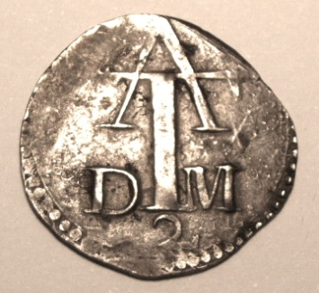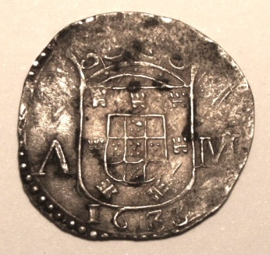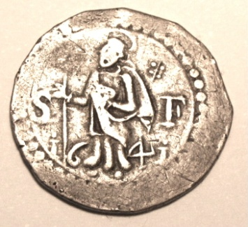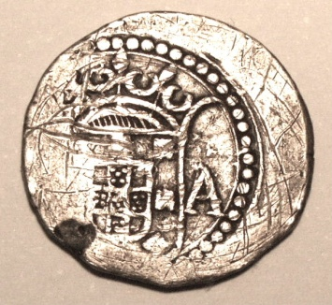
Double Tanga 1633 St Filipe Double Tanga 1641
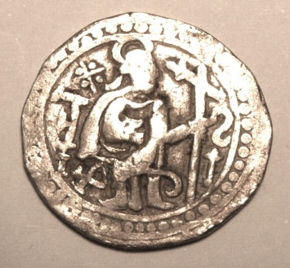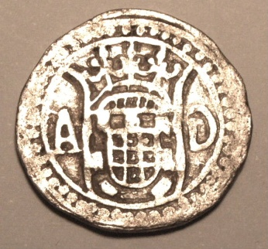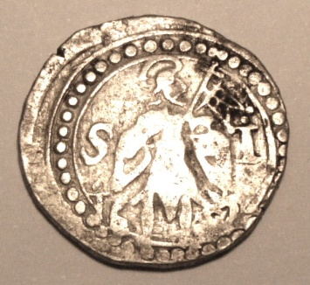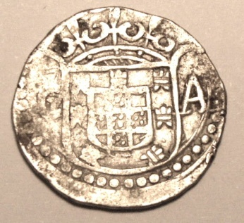
Probable Contemporary Forgery of Double Tanga of 1641 St John Double Tanga of 1651
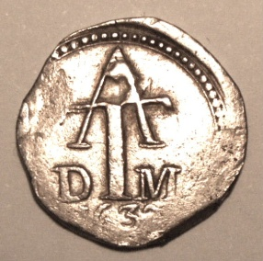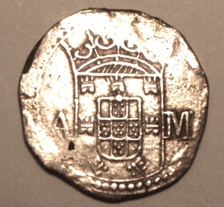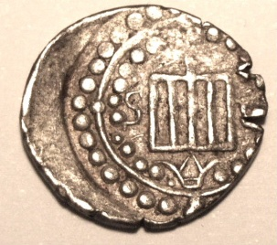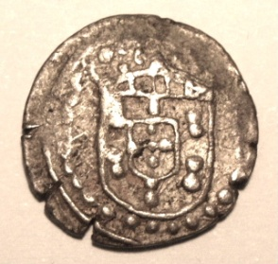
Single Tanga of 1632 Gridiron Tanga of Fort Sao Lorenco

Silver Larins - Although not of Portuguese origin they circulated mainly in the Portuguese period and are included here. Larins were of thick silver wire flattened in the centre area with an Arabic inscription. One silver larin was 1/5 of an 8 reale piece. The undated larin coinage originated in the Persian Gulf and was used in that region and around the shores adjacent to the Persian Gulf as far as India and Lanka during the period 1500-1700. One difference in Lanka is that the larins were almost always bent into a fish hook shape while those from other regions were left straight. The type used in Lanka is shown below.
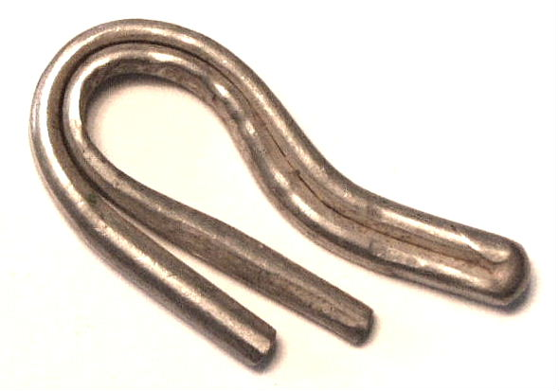
A Silver Larin Used in Lanka

- The Dutch Occupation (1658- 1796)
As mentioned under the previous heading the Dutch started to gradually occupy the Portuguese fortresses in 1638 but their occupation is usually dated from 1658 when they occupied the last Portuguese fortress in Jaffna. The Dutch first got a foothold in Lanka by assisting Rajasinghe II to eliminate the Portuguese power from the island. The King naively assumed that the Dutch, after his aims had been achieved, would abandon Lanka leaving behind just a few small trading posts. As for the Dutch their colonial policy had always been that of gaining political and economic control over the lucrative spice trade to Europe and in this regard, Lanka was the jewel in their crown and so they established themselves as a colonial ruler. The native rulers were not entirely subjugated and moved their courts inland but the Dutch retained control of most of the coastal areas and maritime trade for the next 138 years. The Dutch controlled Lanka through their autonomous trading company the Verenigde Oost-Indische Compagnie or VOC which at the peak of its power in the Far East in 1669 had 40 warships, 150 merchant ships and over 10000 soldiers. The VOC produced a very interesting series of mostly locally produced coinage for use in its colony of Ceilao as follows:
(a) Earliest Dutch Coinage
Prior to 1660 the Dutch authorised the use of the old Portuguese coins counterstamped at Galle, Colombo and Jaffna with the VOC and certain other counterstamps. The collection has one example of a 2 Tanga piece with the VOC counterstamp for Jaffna which is shown in the photo. Dutch counterstamps were also impressed on other current silver trade coins, among which the Sefavid abbasi is noteworthy.
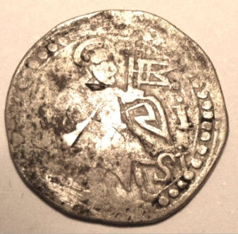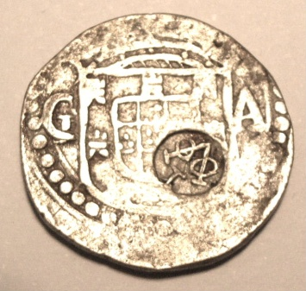
Portuguese St John Two Tanga with Jaffna VOC/I counterstamp

(b) Batavia Dollars – In 1644, owing to a temporary shortage of copper coinage in Lanka, the Dutch East India
Company by a placard dated August 19th, 1644, granted the Chinaman named Conjok the sole right to cast copper
quarter and half stuivers in Batavia for use in Banda, Malacca and Lanka. Strangely enough, a prohibition dated
Sep 21st demonitised this issue just a few weeks after it had started production. There is some conjecture that this
was done due to a scam based on the coin being of lighter weight than that agreed by contract. The coins have on
the obverse a Sword with the words ANNO 1644 BATAVIA in the legend and on the reverse the VOC device with the
words “1/2 St”. Putting this date into historical context it was also the period of the start of the English Civil War
and the Civil War Battle of Lostwithiel was fought on August 21st 1644 at the same moment in history as this coin
had its very brief period of currency. One is shown below:
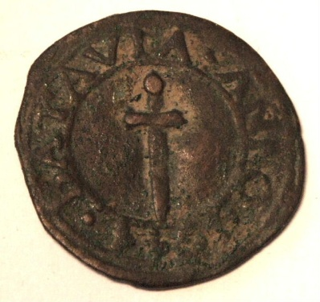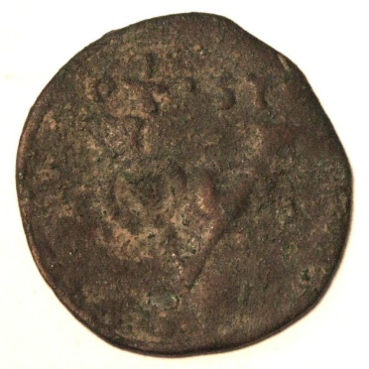
VOC “Conjok” Batavia Half Stuiver
(c) The Pulicat Series
In 1646 the Dutch received permission from the Golconda Sultan to strike coins at Paliakate (Pulicat) on the south east Indian coast with the stamp of the King of Golgonda. This inscription degenerated during the years and the word Allah which was a wavy line in the beginning eventually was completely omitted. The denomination chosen for the Pulicat coinage was the “Kas” with 10Kas = 1stuiver. Denominations of 1,2,4,5,8 and 10 Kas were struck. These Pulicat dumps were essentially for use in the Coromandel area in India but a 10Kas and a 5Kas coin was authorised for Lanka followed later by a 4 and 8 Kas striking. A placard of February 1674 put an end to the issues for Lanka. The collection has an example of a fairly worn 10 Kas dump, two 2 Kas dumps, and four interesting 1 Kas dumps from Pulicat, which were all in use in Lanka. Examples are shown below.
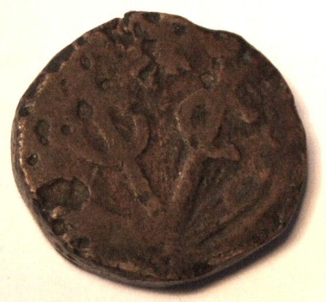.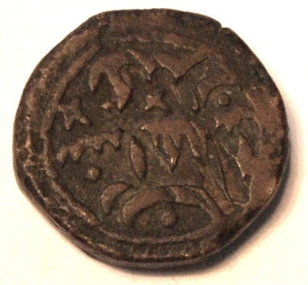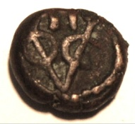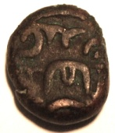 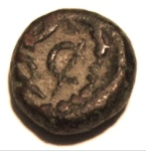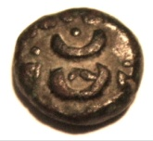
VOC Ten Kas Pulicat Dump VOC Two Kas Pulicat Dump VOC One Kas Pulicat Dump

(d) The Negapatnam Coinage
On July 23rd 1658 the Dutch took Negapatnam, situated on the south east coast of India, from the Portuguese. From 1673 Negapatnam was granted limited minting rights which terminated in 1784 when the Dutch were forced to hand over Negapatnam to the British. During the Dutch occupation two series of copper dump coins were produced. The first of these were called the Kali coins of 1695 which were minted specifically for Lanka. The second was the series of VOC dumps minted from 1700 to 1784 for use in the regions controlled by the VOC. The collection has none of the VOC dumps but has an excellent example of a Kali 1695 two stuiver or 50 cash piece listed by Scholten as RRR and shown below. The obverse shows a highly stylised representation of the Tamil goddess Kali and the obverse states “Negapatnam” in three lines of Tamil script. The coin is very bulky and weighs 53 gms.
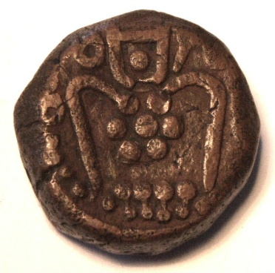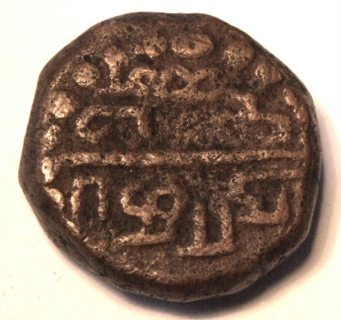
Negapatnam Kali 50 Cash Dump

(e) The Wreath Series
In 1660 the Dutch started minting anonymous undated “dump” style 2, 1, half and quarter stuiver copper coins bearing their value within a wreath on the obverse and the reverse. These were minted until 1720 and are grouped into three wreath types, depending on whether they were minted at Jaffna, Negapatnam or Colombo. An example of the Colombo one stuiver and also of the Jaffna ¼ stuiver are shown.
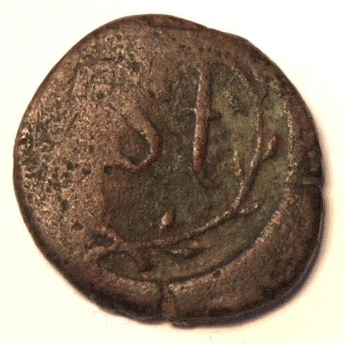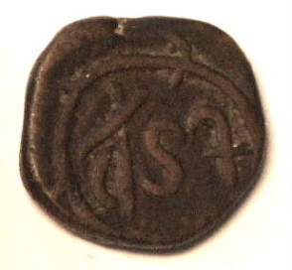
Wreath Series One Stuiver Wreath Series Quarter Stuiver

(f) The Dutch Silver Home Coinage
Throughout its occupation of Lanka the Dutch supplemented locally produced VOC coinage with silver coinage imported from the home country. The most common silver coins by far were the 1 and 2 stuiver pieces which at the time circulated world wide as trade coins and were minted from 1614 to 1793. There are many examples in the collection of the common one and two stuiver pieces. In addition there are three 6 stuiver silver coins from the Netherlands. The earliest of these is a 1733 piece from Zeeland with crowned arms of Zeeland on obverse and on the reverse a lion couchant supporting a hat on a lance with castle mintmark above. The second six stuiver piece is dated 1736 from the province of Holland. It shows a man of war in full sail on the obverse with the arms of Holland separating the Value 6 S and the date above on the reverse. The third six stuiver piece from the province of Zeeland is dated 1791 and also shows a man of war in full sail on the obverse with the arms of Zeeland separating the value 6 S on the reverse. A few examples of this home coinage are shown below.
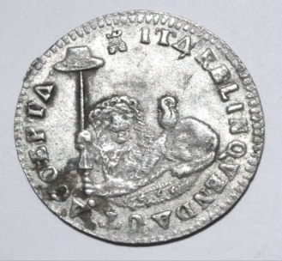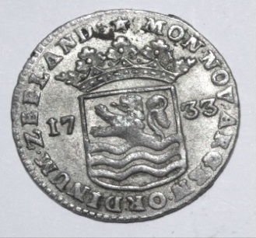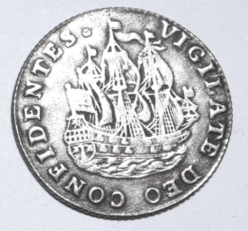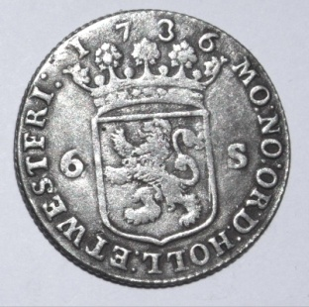

Silver Six Stuiver 1733 Zeeland Silver Six Stuiver 1736 West Friesland

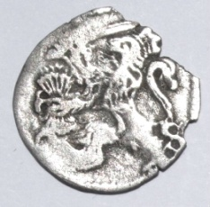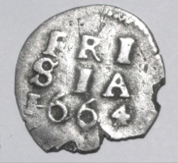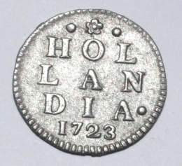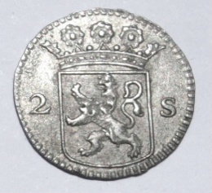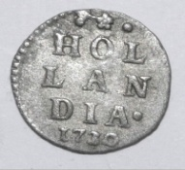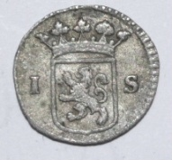
Two Stuivers Frisia 1664 Two Stuivers Hollandia 1723 One Stuiver Hollandia 1730

(g) The VOC Doit copper coinage
From 1726 to 1794 small copper doits or duitens or “challies” were minted for the VOC in the five Netherland provinces of Holland, West Frisia, Zeeland, Utrecht, and Gelderland. They were not current in the Netherlands, being used solely in Lanka, Coromandel, Cochin and Malacca. Due to increased demand, a Half Doit or Duit was also struck in all five provinces. The VOC Doits were rated at 4 to the Stuiver and were minted in huge quantities. The non-VOC doits in the home country circulated 8 to the stuiver. The collection has over 100 examples from all of the states with a wide range of dates. They show on one side the VOC insignia and the date with a mintmark above the insignia, and on the other side the arms of the issuing province. An example of the Doit and the Half Doit from the province of Utrecht are shown in the photos.
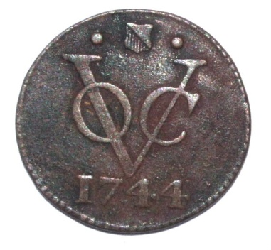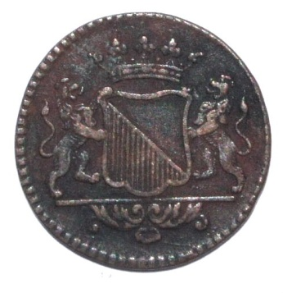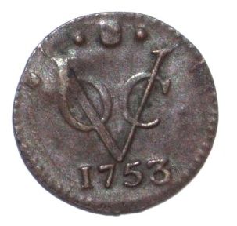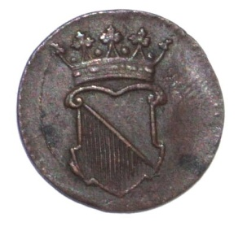
Copper VOC Doit or “Challia” Utrecht 1744 Copper VOC Half Doit Utrecht 1753

(h) The Copper VOC “dump” coinage
Owing to the constantly increasing shortage of small change in the province, in 1783 the council of Colombo decided to locally mint one and two stuiver pieces as well as a ¼ stuiver piece and these are the famous VOC “dump” coins minted on flat chunks of copper. The range of weight of the 1 stuiver dumps in my collection is from 12.03 to 14.11 gms. The exchange rate between the duits and the stuiver was 4 duits to the stuiver. These wonderful dump coins were minted in Colombo, Galle, Trincomalee and Jaffna, with the mintmarks being C,G,T and I respectively. The dumps are sometimes round but are commonly oddly shaped due to the die flattening the soft copper flans in an uneven manner, which in many of these coins also causes part of the inscription to be missing on the flan. Dumps were produced from 1783 to 1795, with the latter date being quite rare. On one side of the dump is the large VOC emblem with the letter mark of the mint above while on the reverse is the denomination in writing and the date. I have seven one stuiver dump coins from the Colombo Mint, and one from the Galle Mint.

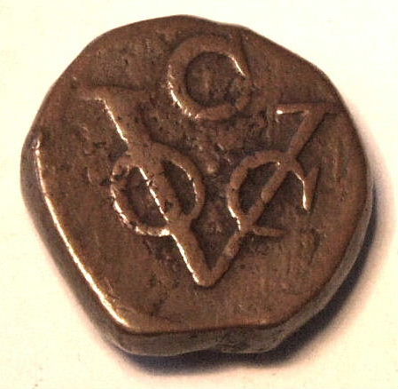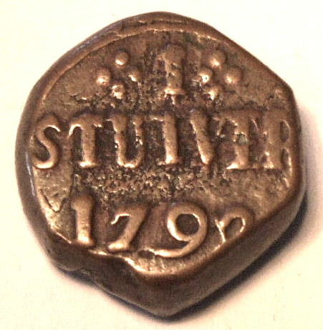
VOC Copper Dump Colombo One Stuiver 1792

(i) Copper Bars of 4 ¾ Stuivers- It was decided by a resolution dated Oct 20th, 1785 to strike small bars of copper
with two round VOC countermarks on either end and declare them current at 4 ¾ stuivers. The bars only had
a short tenure and most were melted down to make the more convenient normal copper dumps. Genuine bars are
therefore extremely rare and nearly all examples seen today, including the one in the collection, shown below,
are almost all certainly reproductions.

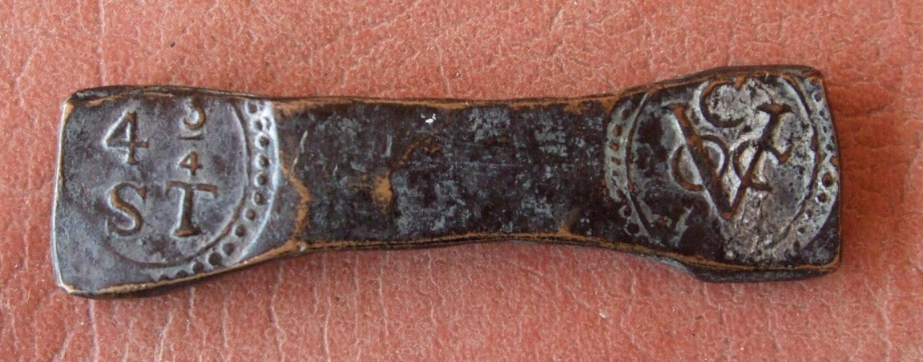
REPRODUCTION VOC 4 ¾ Stuiver Copper Bar

(j) Gold Trade Coins – The two most common gold trade coins used by the Dutch in Lanka were the Venetian Ducat
and the Dutch Ducat. The collection has a beautiful example of each of these coins as follows:

Venetian Ducat – Wt 2.91 gm Obverse - The Doge receiving the gonfalon from St Mark. Around the periphery the
legend SMVENET on left, ALOY.MOCEN on right continued by DVX to the right of the vertical banner which has a
cross on top. Reverse- The standing figure of Christ within convex lens known as a mandorla with 16 stars of 5 points.
The legend reads SITTEPEATQIV on the left and REGISISIEDUCA on the right. The type of mandorla shows that this is
a ducat (known also as a zecchino or sequin) of Alvise Mocenigo IV 1763-1779. It is in EF condition. It is of almost
pure gold of .999 purity.
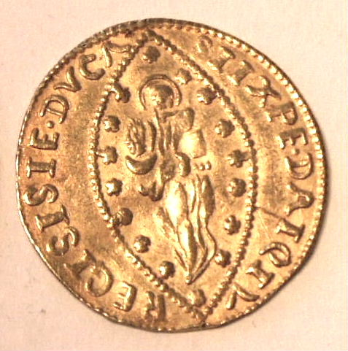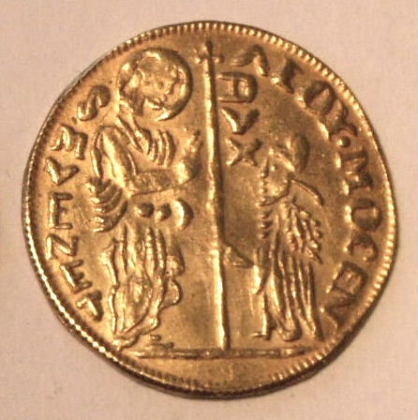
Venetian Gold Ducat of Alvise Mocenigo IV

Dutch Ducat (Utrecht) – Wt 3.48 gm Obverse - Within ornamental square tablet the latin legend
MO:ORD:PROVIN:FOEDER:BELGRAD LEG:IMP. Reverse – A knight facing right standing in armour with a sword in
right hand and a sheaf of arrows in left hand dividing the year of issue 1783. Legend reads CONCORDIA RES
PAR:CRES.TRA: It is of almost pure gold of .986 purity and in EF condition.

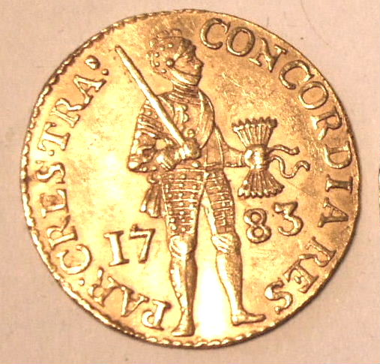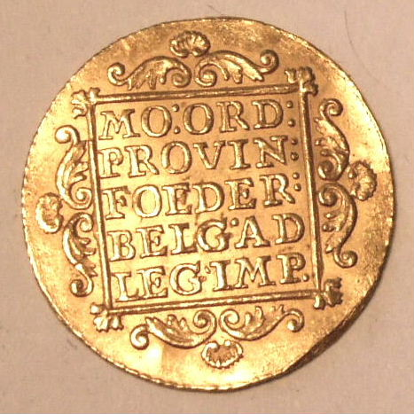
Dutch Gold Ducat (Utrecht Mint) 1783

- The British Colonisation
In 1795, England was at war with France and as a result of the French occupation of Holland in 1795 and the resultant formation of the new French controlled Batavian Republic in Holland, England sent a fleet to the far east to take over all of the Dutch colonial possessions in that region. By 1796 all of the Dutch Settlements in Lanka had been peaceably taken over and the English annexed Lanka to the Presidency of Madras. The appointment on 19th April, 1798, of a governor and Commander in Chief in Calcutta had the effect of raising British Lanka to the position of an Indian Presidency under the direction of the Governor General of the East India Company at Calcutta.
In 1802, British Lanka passed under the control of the Secretary of State for the Colonies and finally, on 2nd March, 1815, the cession of the Kandy Provinces placed the whole island under British sovereignty.

The East India Company essentially retained the Dutch denominations based on the Rix-dollar of 48 stuivers. The first coinage struck for the island under British rule consisted of copper and silver “dumps” minted locally under contract starting in 1801. The copper was minted into pieces of 4, 2, and 1 stuiver, with the respective denomination shown on the copper dump coins of 12, 24, and 48, representing 1/12, 1/24, and 1/48th of a Rix-dollar and the silver coins minted were Rix-dollars and half Rix-dollars. A double rix dollar silver dump was also minted in 1808 and 1809. The copper contracts continued until 1805 and the silver contracts until 1809, and in 1811 a local government mint was set up and operated until 1816. The collection has the following examples:
- Copper Dump 1/12 Rix-dollar, 1811
- Copper Dump 1/24 Rix-dollar, 1801
- Copper Dump 1/48 Rix-dollar, 1803
(d) Silver Dump 1 Rix-dollar, 1808
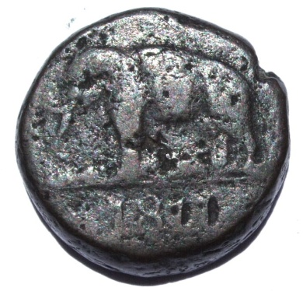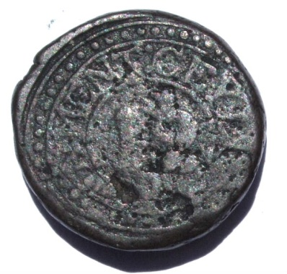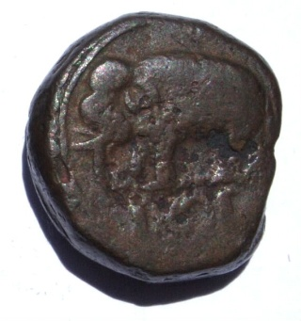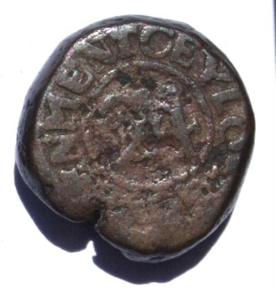
Copper Dump 1/12 Rix Dollar 1811 Copper Dump 1/24 Rix Dollar 1801
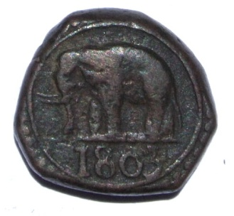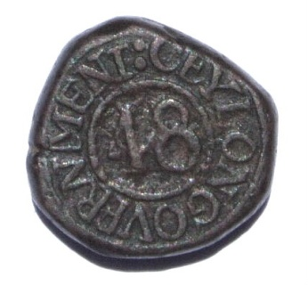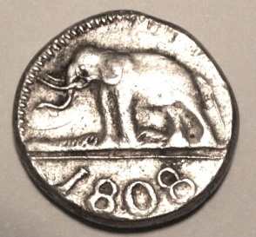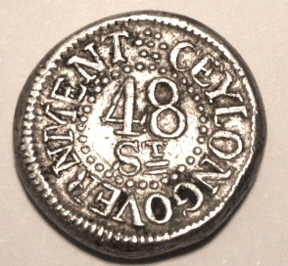
Copper Dump 1/48 Rix Dollar 1803 Silver Dump One Rix Dollar 1808

In 1801, the first coinage to be struck in England for Lanka was demanded by Governor North and minting of this coinage occurred at Mathew Boultons Soho Mint in 1802. It comprised 1, ½, and ¼ stuiver copper coins designated 48th, 96th, and 192nd of a Rix-dollar respectively. The collection has two examples of the “192” coins both dated 1802.
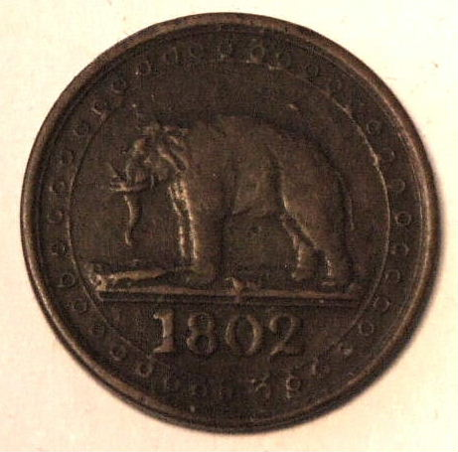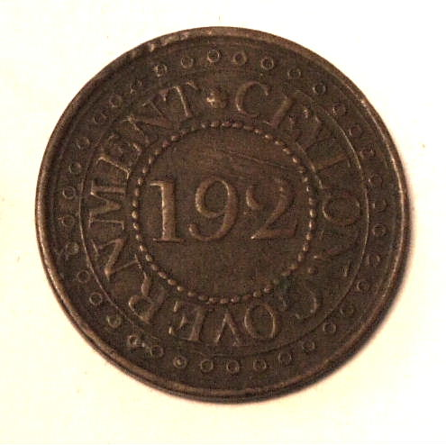
1/192 Stuiver Coin Minted in London 1802

By 1814, the scarcity of small silver and copper coins was causing the Government great concern. Consequently silver “fanam” token coins were struck locally and issued to pass at 12 to the Rix-dollar (equivalent to 4 stuivers). The collection has one example of this token coinage. It states blandly “FANAM” on one side and “TOKEN” on the other of these very small silver coins, with this example weighing only 0.52 gm. Minting ceased in September 1815.
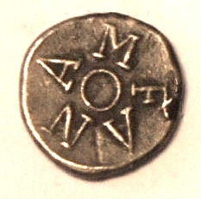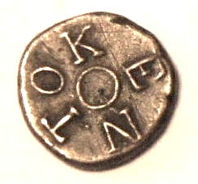
Tiny Silver Fanam Token Coin (Much enlarged)

Also In 1814 an Order in Council authorised a silver and copper coinage for Lanka from the Royal Mint to the extent of 10000 Rix-dollars in silver and 200000 Rix-dollars (value) in copper. A few silver Rix Dollars were struck in 1815 but never circulated, however the copper coinage of 2, 1, and ½ stuiver denominations was struck with the profile of George III. The metal for this Lanka coinage was obtained from demonitised English Halfpence. The collection has good examples of each of the three denominations dated 1815, which was the only mint year for the coins. The One Stuiver and Half Stuiver are shown.
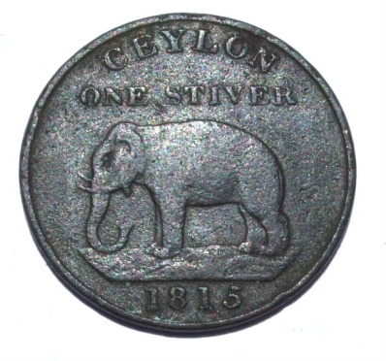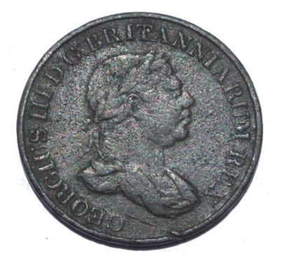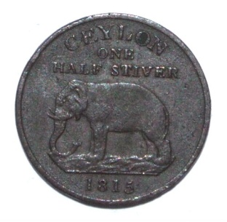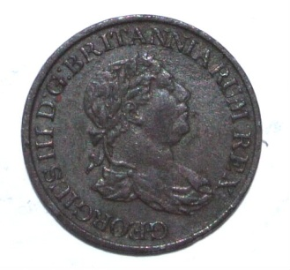
One Stuiver George III 1815 Half Stuiver George III 1815

In October 1821, a treasury letter sanctioned a silver Rix-dollar to be struck for Lanka at the Royal Mint. Only one date of 1821 was ever minted featuring the profile of George IV. There is an excellent example in the collection.

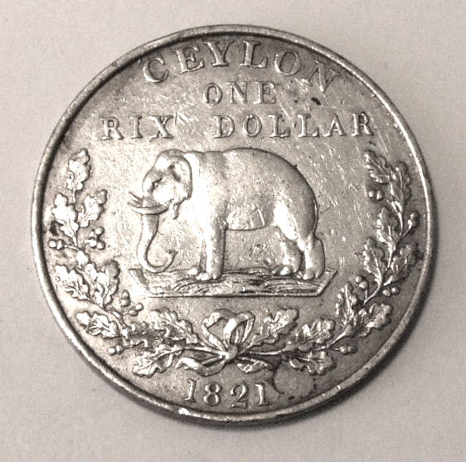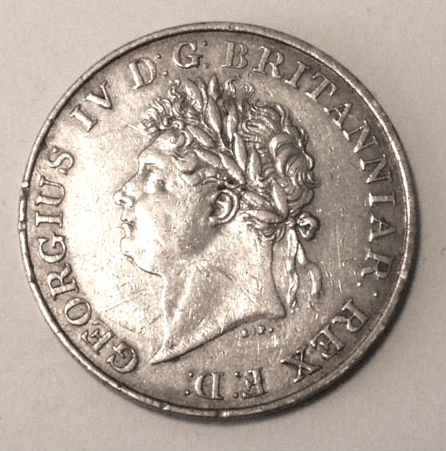

Silver Rix- Dollar Minted in London 1821

In 1825 an Order in Council directed that all public accounts should be kept in sterling. The Lanka Rix-dollar for the purposes of exchange was rated at 1shilling 6d sterling. Following this order, sterling coins, both silver and copper were imported from England for normal use, but two copper denominations were minted specifically for Lanka. These are the Half-Farthing and the quarter farthing of which I have good examples of each. In addition, the small 1 ½ pence minted from 1834-1837 in the reign of King William IV was the only small value silver coin minted specifically for Lanka, and the collection has a good example of that coin. Examples of the above British Coinage minted only for Lanka are shown in the photos below.
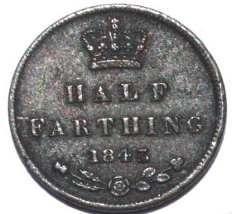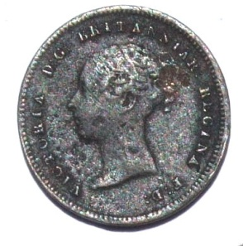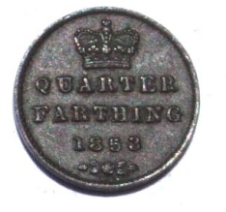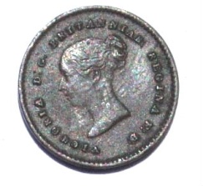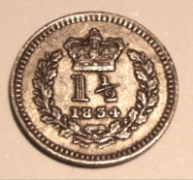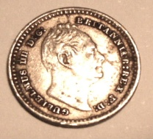
Half Farthing 1847 Quarter Farthing 1853 Silver 1 ½ Pence 1834

After changing to Sterling in 1825 the wide use of sterling coins lasted only a few years as government expenditures exceeded revenue and sterling coins became very scarce. In an effort to correct this situation large imports of British-Indian Rupees were made. This coinage from India was used unofficially until 1870 when it was declared legal currency in Lanka. The currency system thus reverted in 1870 to the Indian currency area to which it naturally belongs and was not rescinded until 1915.

- Forgeries
There are a large number of coin forgeries on the market today worldwide, often sold through ebay, but also by vendors selling to tourists in the tourist shops and in the street. Sri Lanka is no exception. Forgeries fall into two categories, contemporary and modern. Contemporary forgeries are those made during the same era as the copied coin. These can have some value depending on their use. Modern forgeries are those made within the last few decades trying to replicate old coins of any country and are quite worthless. An expert can usually tell the difference between a fake coin and a real one simply through experience. On the other hand some modern forgeries are well made and difficult to recognise. For this reason the “provenance” or “pedigree” of any coin is important to help establish that it is genuine. In particular it is very helpful if you know that a coin has come from the collection of a previous respected owner or that it has been uncovered in an archeological dig. Forgeries, even good ones, can often be identified by the repetition of certain shapes and/or features on the fake coins which have all been struck from the same fake die. As Dr. Ratnatunga points out in his excellent website it is much easier to prove a coin to be fake than to prove that it is genuine. My own view is that aside from the obvious forgeries, other coins deserve to be considered genuine unless proven otherwise. I have a number of obvious forgeries in my collection which I purchased as forgeries for comparison purposes and are labelled as such in my trays. Two of these forgeries are the 4 ¾ stuiver bar labelled as a reproduction in chapter 17 of this paper as well as a valuable contemporary forgery (labelled as such) as Coin 4 in the Indo-portuguese Chapter 16.
Other than these two coins mentioned above all the other coins photographed in the paper have a good provenance and are presented as genuine. If any prove later to be forgeries this will be acknowledged and identified in the paper and in the trays. I have purchased no coin additions to my Lanka collection from any source since 1975.

- Acknowledgements and References
This paper contains no original research. A number of existing published sources contain excellent and detailed information regarding the coinage and numismatic history of Lanka but are written in considerable detail for the specialist numismatist and none provide a coherent condensed view for the non-specialist reader. I hope that this summary provides such a need. The coin illustrations used are all of coins from my own extensive collection but for the text I have borrowed generously from the following sources:
- Lanka Coins and Currency - H.W. Codrington 1924.
- Price Catalogue of Ancient Coins of Lanka – T. M. De Silva Abeywardene 1952
- Website “Lakdiva Coins” provided by Dr. Kavan Ratnatunga. This is an excellent website set up by a Sri Lankan numismatic expert and is recommended for anybody seeking more detailed information about Sri Lankan Coins.
- Website “Sirimunasiha.wordpress.com”
- C. Scholten: The Coins of the Dutch Overseas Territories, 1601-1948
- The ZENO Oriental Coins Website at http://www.zeno.ru/showgallery.php?cat=875
I have also had personal communication with Mr. Jan Lingen (a well known Netherlands based expert and author on colonial and local coinage of South East Asia ) concerning a number of facts relating to my article.

MAP OF LANKA SHOWING MAJOR TOWNS OF INTEREST