A Silver coin commemorating Anagarika Dharmapala’s 150th Birth Anniversary.
By Kavan Ratnatunga
A commemorative Rs 500/- sterling silver crown size frosted Proof Non-circulating Legal Tender (NCLT) coin was issued by Central Bank of Sri Lanka to mark Srimath Anagarika Dharmapala’s 150th Birth Anniversary. Born in Colombo on 1864 September 17th, Don David Hewavitharana, the non-violent Sinhala Buddhist national leader changed his name to Anagarika Dharmapala (Homeless protector of Dharma) and founded the Mahabodhi Society in 1891 to protect Bodh-Gaya. He died at Sarnath in 1933 December, where he had been ordained a bhikkhu that same year.
The coin was presented by Hon. Minister of Finance, Ravi Karunanayake to Prime Minister of India Narendra Modi at the Maha Bodhi Society, Colombo, during his state visit to Sri Lanka on 2015 March 13th . By coincidence Modi was born on 1950 September 17th.
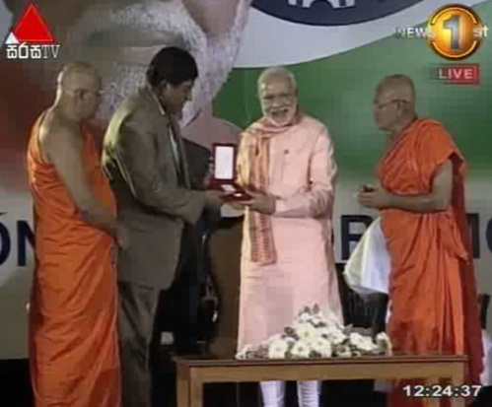
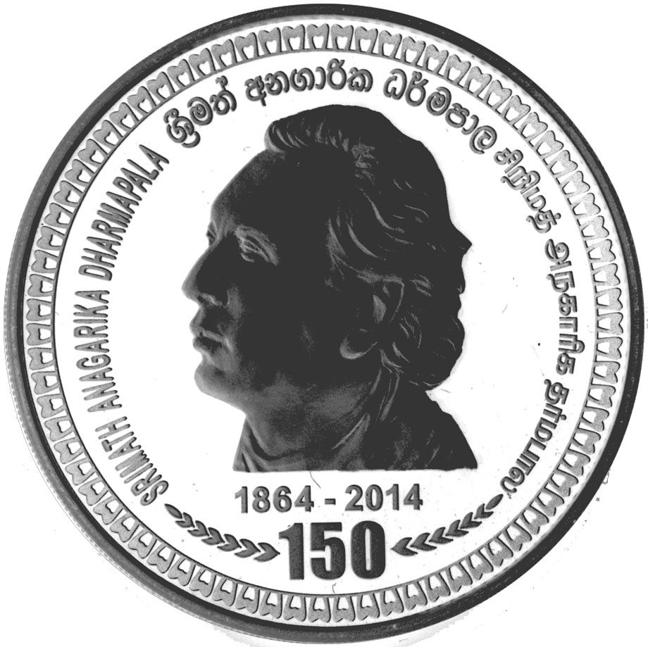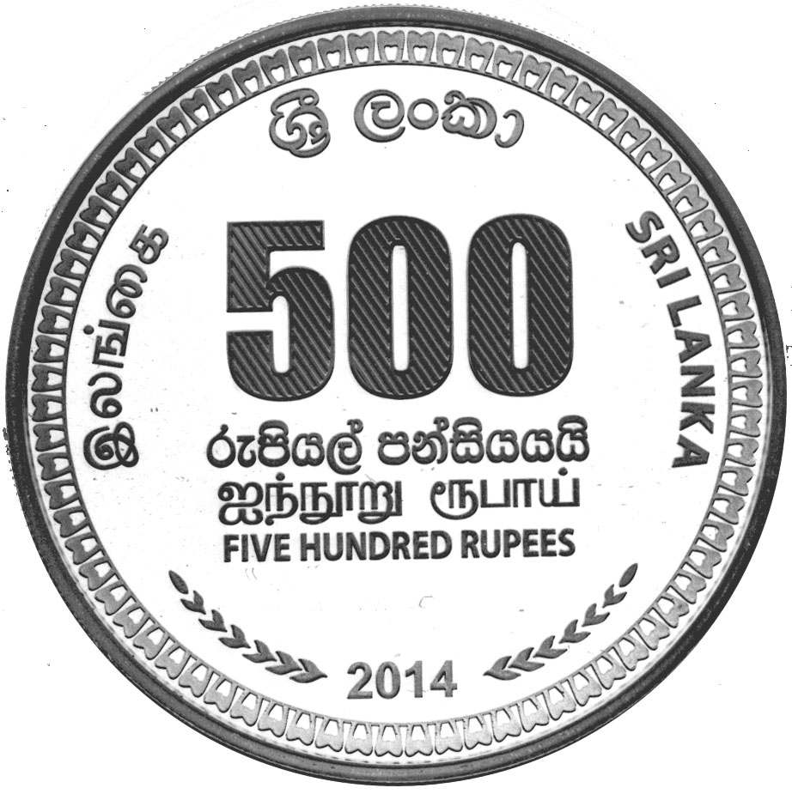

Obverse : At center portrait facing left. The words SRIMATH ANAGARIKA DHARMAPALA appear within upper part along the periphery in Sinhala at apex and Tamil and English to right and left. 1864 - 2014 appears below with 150 with 6 arrows heads on either side pointing towards it, along the artistic border around the rim.
Reverse : Large Face Value 500 in numerals and FIVE HUNDRED RUPEES below in three lines in Sinhala, Tamil and English. Along the upper part along the periphery the name SRI LANKA in Sinhala at apex, with Tamil and English to left and right. 2014 appears at bottom with 6 arrow heads on either side pointing towards it, along the artistic border around the rim.
The limited 1500 coins were struck at Mincovna Kremnica in the Republic of Slovakia, with one ounce of sterling silver to the Buddha Jayanthi Rs5 silver coin size. Enclosed in a circular coin capsule, it is embedded in red velvet with white satin inside cover of a red leatherette covered 6.5cm square spring hinged presentation box. A printed numbered Certificate of Authenticity contains the specifications and the text in English, Sinhala and Tamil. The frosted proof coin should never be removed from capsule and touched by hand as finger prints will ruin the numismatic value.
This coin has been issued by CBSL six months after the Birth Anniversary on 2014 September 17th, on which date both Sri Lanka and India issued stamps in Honour of Anagarika Dharmapala. The coin was ready for issue on December 24th . But due to the presidential elections the release was "postponed due to unavoidable circumstances".
Coins were sold to public at CBSL Economic History Museum from March 16th for the issue price was Rs 8700/- . They were initially sold at one coin per person in queue. This was relaxed later in the day when the demand appeared to be not as great as for the Pope Coin, released in January and which sold out in few days.
For more details on this and all Ceylon/Sri Lanka coins visit the author’s Educational website at http://coins.lakdiva.org

